Renju lesson on March 14, 2002

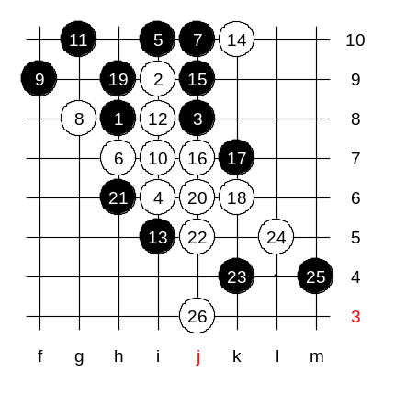
Hello everyone! Welcome to Online Renju Class. Hello everyone, we will now begin our lesson. Last time we studied about the 4th move to i6. We realized that both 5-i7 and 5-i8 are sufficient for black win. I will introduce on more 5th move today. That is 5-i10. This is not sure black win, but gives black advantage. The advantage is good enough so that good player can turn it into black win. Move 6-h7 or 6-j7 is the only one that does not lose. Before I considered some active moves for black, such as 7-j10. Now I ask you, what is white’s plan here? The plan is control style indeed. The 8th and 10th move set up the controls. Span showed us the final VCF.

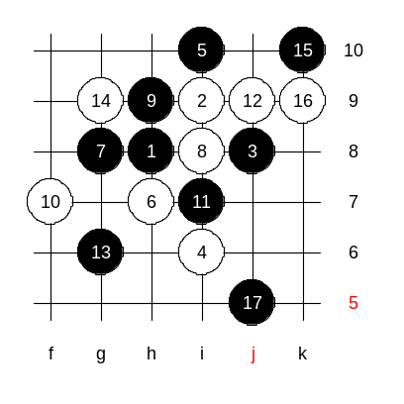
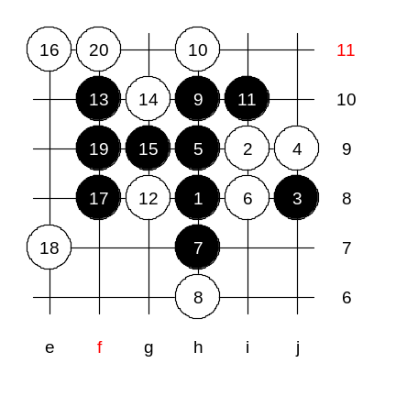
We realized that active 7th move brought trouble for black. Therefore we need another plan for black. It seems black has to take g8 point. Move 9-h9 is natural, too. Should white play a four or not? By the 13th move the position is calmer a bit, and black continues with positional style. How can white defend now? yes, blocking the 3x3 point is usually the strongest defense. And now? Moves 16-k9 and 16-L10 are the only ones worth to look at. Ok we pick k9. The j5 point is the key connecting point. Black has the unused upper side force, and promising space below. j5 stone helps to connect the upper force and lower space. Anyway, after 17th move there is a positional style game with black advantage, but no sure win. Actually we do not need to dig too deep in such style, because it is inconclusive. All we need to have is the evaluation here. Right?

We can now end with this 4th move, ok? We change 4th move now. Move 4-j9, an interesting move. Is here anyone who can win here as black? Ok we let civsnail try. Move 5-i7 is the main 5th move and wins fast. Does not look easy.

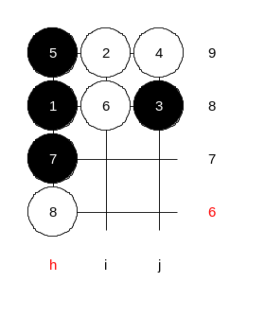
Who else wants to try to win? Oster666 wants to try. But he doesn’t move yet. I assure you black has win here.

OK, ASV tries.
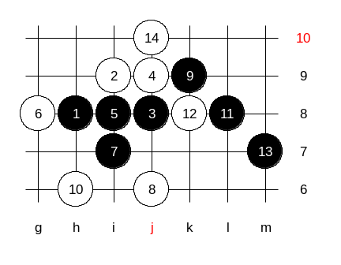
Who thinks 5-i8 is black win? Wow, all of you think so. But I don’t.
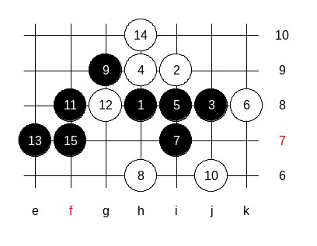
Let me introduce the problem here. According to i6 theory, the 7-i7 wins. But not in i3 opening. :o) Surprising 14!!! and no win! easy win. But not here. Japanese theory did not solve this puzzle. Therefore I had to dig a lot to prove black win for my book.

Here the win is easy.

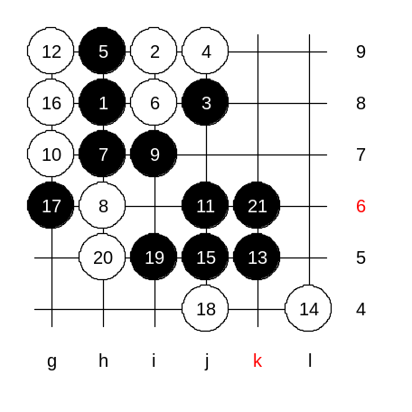
I searched a lot, and finally gave up the 5th move at i8. Useless. And I found another winning idea, from 5-h9. None of the previous renju books in history mention any solution here. You are the first ones to see it. Moves 7 and 9 look primitive, but the following is amazing. 10-g8 is forced. OK, we go 10-g7 first, as you request.

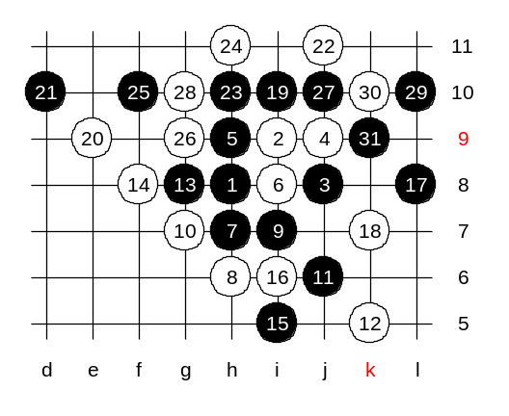
Another 12th. Beautiful 15th gives win in two sides. Move 16 is forced, to avoid two-side win. But then easy win follows. Who is ready to show? :) tunnet99 shows. Good. This is win.

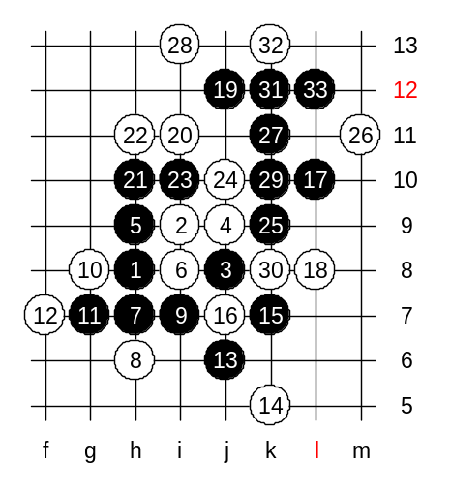
Can we play 10-g8 now? In my opinion, 10-g8 is the strongest defense, and it took me long time to find win. Beginning moves are easy. 17-L10 the only way to win. Black needs the i10 point to ensure win.

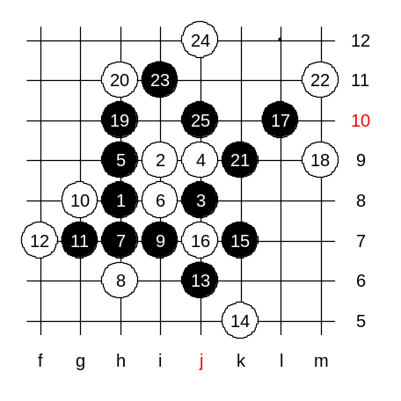

This 18th is another choice. No other good choices, right?

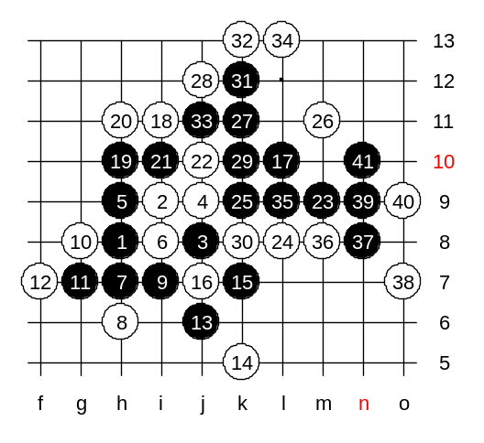

One more 18th move. Here’s win.

We will continue i3 analysis next week. The lesosn is over now, thank you all for joining. I am now about to announce credit points.
The following students are awarded today's participation credit point: pantrike, shuwang, tunnet99, luwenzhe, shadewawa, coco_yuang, Rehnstedt, ASV777, yun_shou, moocheng, scm2000, shuker, Fredde, hobbang, longj, ocn, Oster666, civsnail, Gawa, yyfcsd, guminzhao, heroabro, ZenoaWilu, farmer_, sulane, Affine, F_Westberg, Ikon.

